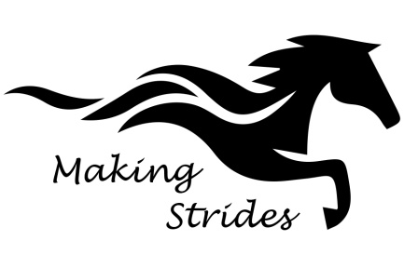
Volunteer/Staff Information Form and Health History

Name: Date:
Address:
Date of Birth: Phone: (H) Cell
Employer/School:
Email:_________________________________________
Parent/Legal Guardian/Caregiver Name:
Address (if different):____________________________________________Cell: ___________________________
How did you learn about the program?

Health History

Please describe your current health status, particularly regarding the physical/emotional demands of working in an equine-assisted program. Address fitness, cardiac, respiratory, bone or joint function, recent hospitalizations/surgeries
or lifestyle changes.

Allergies:

Medications:

I understand that the information provided is accurate to the best of my knowledge. I know of no reason why I should not participate in this center’s program.

Signature: Date:

Parent Signature (if under 18 yrs of age) ____________________________________________________________

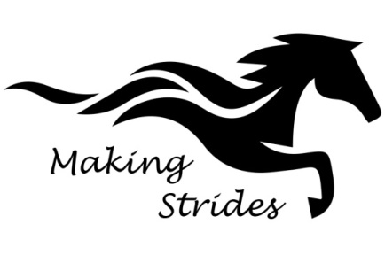

LIABILITY RELEASE
I hereby certify that being aware of the risks and exposures to personal injury involved through equestrian activities I hereby release Making Strides, Judy Matthijssen, her employees and other volunteers that are assisting in any official capacity on their behalf, from all and every claim for damages which may occur to me or my property in any connection with lessons, clinics, practices, schooling or any work with horses on the properties or away from the properties of TRADE.
Signature_________________________________________________Date________________________

Parent Signature (if under 18 yrs of age) ___________________________________________________________

Photo Release

I ❏ DO
I❏ DO NOT
consent to and authorize the use by Making Strides of any and all photographs and any other audio/visual materials taken of me for promotional material, educational activities, exhibitions or for any other use for the benefit of the program.

Signature: Date:

Parent Signature (if under 18 yrs of age) ___________________________________________________________

Confidentiality Agreement
I understand that all information (written and verbal) about participants at this PATH Intl. center is
confidential and will not be shared with anyone without the expressed written consent of the participant and his/her parent/guardian in the case of a minor.

Signature: Date:

Parent Signature (if under 18 yrs of age) _____________________________________________________________

